Creating Boundaries for Teens
by Parenting Today Staff | on April 4, 2016 | in Uncategorized

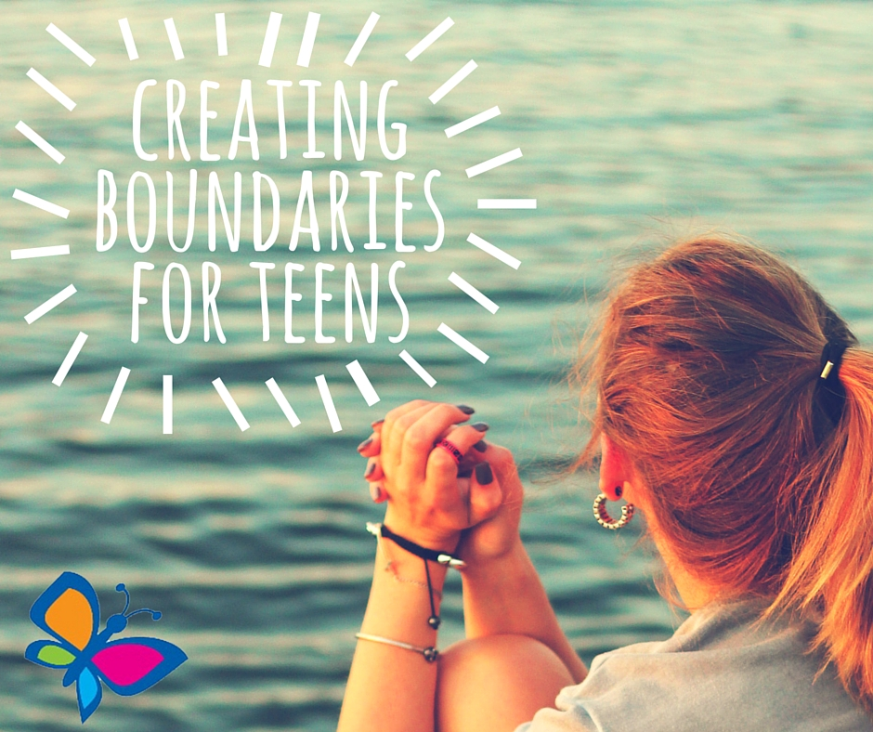
By Gail Fero

Children of all ages need boundaries, but teens need them most of all. Though it’s tempting, and may seem logical, to give your teen fewer restrictions, this will create more problems further down the line for them and for you. Teenagers are still not adults yet, and though it is important to give them more freedoms than you would a younger child, you need to create, discuss, and enforce boundaries with your teenagers.

The teenage years can be the most difficult for both the teen and their family. But the tantrums, cold shoulders, and shouting matches should remind you that you’re still dealing with a child. Your teenager needs parameters and it’s your job to create them. Keep your teenager’s safety and health the focus of your boundaries. The limits you choose will differ for each teen, even if only slightly. This may create the appearance of unfairness, but it’s necessary. Every teenager is different and will face different dangers due to their personality. For some it might be susceptibility to peer pressure, for others it might disregard for their own health.

An important part of creating effective boundaries for your teen is to discuss them with your partner before deciding. You both need to understand what behaviors will and won’t be acceptable, and present a united front, backing each other in enforcing these boundaries. There should be no misunderstandings between the two of you, because this can cause confusion or make room for manipulation. When you both have a good handle on the limits you want to put in place, discuss them with your teen. Be clear about what will be expected of them, the reasoning behind the demarcation, and the consequences of their actions should they defy you. Though they might not agree or be happy with you, creating the dialogue should help you enforce your boundaries. Because teens are in that awkward stage between child and adult, involving them in discussions about the rules of the house will make them feel more in control, or at least aware of what’s going on.

Once you have your rules in place, it’s necessary to enforce them. Consistency and reliability are as important to teenagers as the boundaries themselves. With so much changing around them, you need to remain steadfast and dependable so your teen knows you are serious about the rules.

Teens require just as close parenting as any younger child. They are at risk because they are between childhood and adulthood. Though they might not want to admit it, they are still children and need you to parent. Creating boundaries should be about their safety and their health. Discuss your rules with your teen, telling them why you’re insisting on this behavior and these boundaries. Let them know it’s for their well-being and because you care. Don’t allow tantrums or arguments to deter you in enforcing these rules. Stay consistent and you’ll see the results that you’re looking for.

